T-Shirts for kids

 |  |  |  | 90 | 104 | 116 | 128 | 140 | 152 | 164 | TOTAL
Grand total kids t-shirts |  |  |  | 1.025 | 19.905 | 22.946 | 16.898 | 19.064 | 24.046 | 15.412 | 119.296

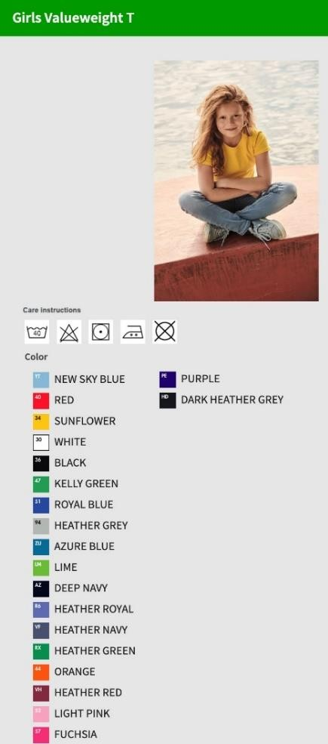  Style | Picture | 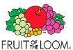  Brand & style description | Colour | Colour Desc | 90 | 104 | 116 | 128 | 140 | 152 | 164 | TOTAL
0610050 |  |  | ZU | Azure Blue |  | 105 | 2.359 | 72 |  |  |  | 2.536
0610050 |  |  | 36 | Black |  | 784 | 708 |  | 2 | 18 | 388 | 1.900
0610050 |  |  | HD | Dark Heather Grey |  | 80 | 340 | 145 | 974 | 2.531 | 72 | 4.142
0610050 |  |  | AZ | Deep Navy |  | 1.975 | 1.816 | 1.268 | 810 | 897 | 1.326 | 8.092
0610050 |  |  | 57 | Fuchsia |  | 108 | 243 | 386 |  | 359 |  | 1.096
0610050 |  |  | RX | Heather Green |  | 139 | 122 | 11 | 509 | 841 | 1.666 | 3.288
0610050 |  |  | 94 | Heather Grey |  | 1.128 | 1.206 | 1.000 | 205 | 177 | 570 | 4.286
0610050 |  | Kids valueweight t-shirts | VF | Heather Navy |  | 103 | 80 | 317 | 96 | 1.736 | 193 | 2.525
0610050 |  |  | VH | Heather Red |  | 136 | 144 | 3.060 | 2.250 | 1.648 | 1.425 | 8.663
0610050 |  | VE / PU: 72 Stück | R6 | Heather Royal |  | 760 | 131 | 653 | 1.023 | 1.430 | 1.579 | 5.576
0610050 |  |  | 47 | Kelly Green |  | 340 | 1.381 |  | 1.364 | 222 | 144 | 3.451
0610050 |  | Weiß: 160 g/m² | 52 | Light Pink |  |  | 72 | 1.094 | 856 | 2.003 |  | 4.025
0610050 |  |  | LM | Lime |  | 148 | 3.891 | 168 |  |  | 226 | 4.433
0610050 |  | Farbig: 165 g/m² | 44 | Orange |  | 2.837 | 2.023 | 568 | 216 | 1.579 | 469 | 7.692
0610050 |  |  | PE | Purple |  | 115 | 89 |  |  | 2.324 | 423 | 2.951
0610050 |  | 100 % Cotton;  Heather grey 97 % Cotton, 3 % PES; HD, VF, R&, RX, XH = 50 %  Cotton, 50 % PES | 40 | Red |  | 1.924 | 354 |  |  |  |  | 2.278
0610050 |  |  | 51 | Royal Blue |  | 888 | 923 | 15 |  | 576 | 412 | 2.814
0610050 |  |  | YT | Sky Blue |  | 251 | 130 |  |  |  |  | 381
0610050 |  |  | 34 | Sunflower |  | 1.040 | 2.052 | 1.129 | 63 | 418 | 129 | 4.831
0610050 |  |  | 30 | White |  | 703 | 1.052 | 878 | 47 | 2.641 | 2.598 | 7.919
Total quantity 610050 |  |  |  |  |  | 13.564 | 19.116 | 10.764 | 8.415 | 19.400 | 11.620 | 82.879

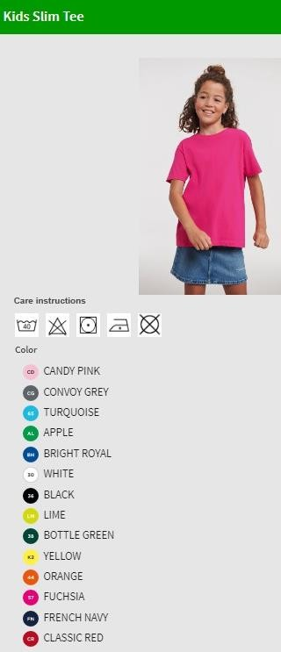  Style | Picture |   Brand & style description | Colour | Colour Desc | 90 | 104 | 116 | 128 | 140 | 152 | 164 | TOTAL
0R155B0 |  |  | 36 | Black | 43 | 338 | 323 | 9 | 978 |  | 390 | 2.081
0R155B0 |  |  | 38 | Bottle Green | 134 | 78 | 117 | 992 | 1.148 | 587 | 207 | 3.263
0R155B0 |  |  | BH | Bright Royal | 26 | 2.601 | 95 | 20 | 771 | 1.219 | 606 | 5.338
0R155B0 |  | Kids slim tee | CR | Classic Red | 203 | 109 | 9 | 120 | 167 | 20 | 310 | 938
0R155B0 |  | VE / PU: 100 Stück | CG | Convoy Grey | 222 | 1.580 | 130 | 49 | 132 | 1.168 | 249 | 3.530
0R155B0 |  | Weiß / White: 140 g/m² | FN | French Navy | 91 | 84 | 2.153 | 811 | 2.352 | 31 | 276 | 5.798
0R155B0 |  | Farbig / Colour: 145 g/m² | 57 | Fuchsia | 84 | 62 | 77 | 1.319 | 114 | 54 | 210 | 1.920
0R155B0 |  | 100 % Cotton;  Light Oxford 93 % Cotton, 7 % Viscose | 44 | Orange | 147 | 1.427 | 58 | 1.460 | 2.923 | 47 | 154 | 6.216
0R155B0 |  |  | 30 | White | 75 | 62 |  | 95 | 990 | 106 | 366 | 1.694
Total quantity OR155 BO |  |  |  |  | 1.025 | 6.341 | 2.962 | 4.875 | 9.575 | 3.232 | 2.768 | 30.778

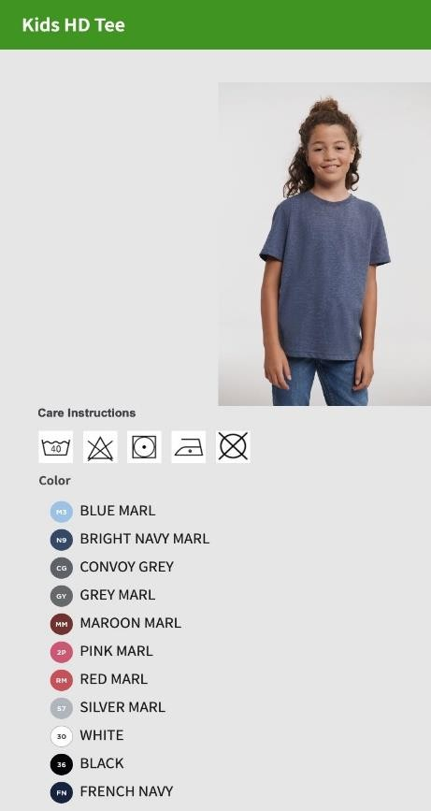  Style | Picture | Brand & style description | Colour | Colour Desc | 90 | 104 | 116 | 128 | 140 | 152 | 164 | TOTAL
OR165BO |  |  | 36 | Black |  |  | 61 | 138 | 155 | 104 | 127 | 585
OR165BO |  |  | M3 | Blue Marl |  |  | 84 | 127 | 292 | 204 | 72 | 779
OR165BO |  |  | N9 | Bright Navy Marl |  |  | 126 | 127 | 114 | 106 | 42 | 515
OR165BO |  | Kids HD tee | CG | Convoy Grey |  |  | 55 | 62 | 36 | 59 | 59 | 271
OR165BO |  | VE / PU: 36 Stück | FN | French Navy |  |  | 54 | 81 | 30 | 55 | 58 | 278
OR165BO |  | Weiß / White: 155 g/m² | GY | Grey Marl |  |  | 72 | 105 | 175 | 178 | 212 | 742
OR165BO |  | Farbig / Colour: 160 g/m² | MM | Maroon Marl |  |  | 66 | 104 | 50 | 113 | 59 | 392
OR165BO |  | 65 % Polyester 35 % Cotton | S7 | Silver Marl |  |  | 111 | 140 | 130 | 162 | 78 | 621
OR165BO |  |  | 30 | White |  |  | 239 | 375 | 92 | 433 | 317 | 1.456
Total quantity OR165 BO |  |  |  |  |  |  | 868 | 1.259 | 1.074 | 1.414 | 1.024 | 5.639

GRAND TOTAL QUANTITY KIDS T-SHIRTS, all 3 Styles |  |  | 1.025 | 19.905 | 22.946 | 16.898 | 19.064 | 24.046 | 15.412 | 119.296

Packing Info: goods are packed in bundles mostly 36pc / 72pc / 100 pc per carton; 1 Style / 1 color / 1 size per carton

